**Assignment Day 5**

1. GROUP BY with WHERE - Orders by Year and Quarter

Display, order year, quarter, order count, avg freight cost only for those orders where freight cost > 100

select

Extract(Year from order_date) as Order_year,

Extract(Quarter from Order_date) as Order_quarter,

count(order_id) as order_count,

round(avg(freight) :: numeric,2) as Average_freight_cost

from orders

where freight > 100

group by order_year,order_quarter

order by order_year,order_quarter

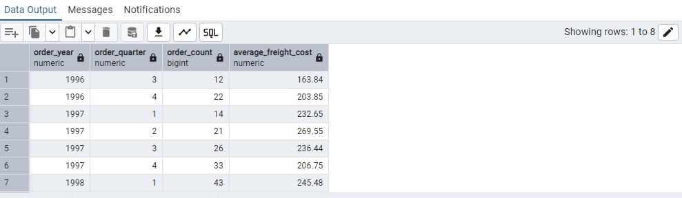

2. GROUP BY with HAVING - High Volume Ship Regions

Display, ship region, no of orders in each region, min and max freight cost  
 Filter regions where no of orders >= 5

select ship_region as ship_region,

count(ship_region) as Order_count,

Min(freight) as Minimum_Freight_cost,

Max(freight) as Maximum_Freight_cost

from orders

Group by ship_region

having count(ship_region)>=5

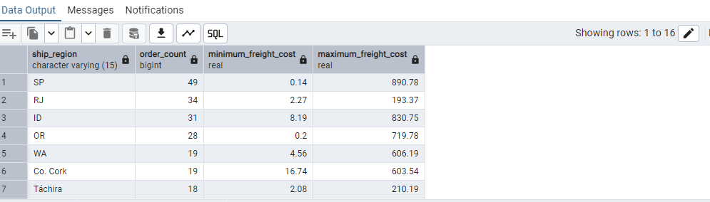

3. Get all title designations across employees and customers ( Try UNION & UNION ALL)

Union

select contact_title as designation from customers

Union

select title from employees

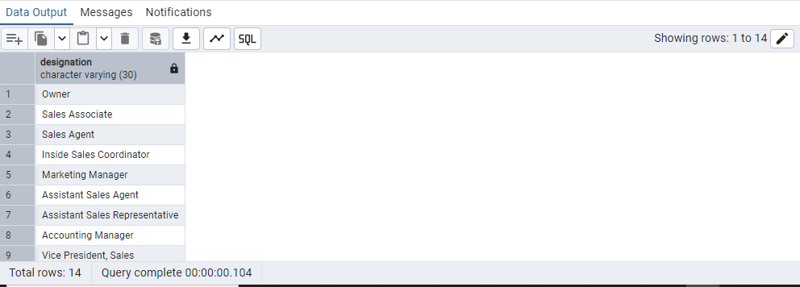

Union All

select contact_title as designation from customers

Union all

select title from employees

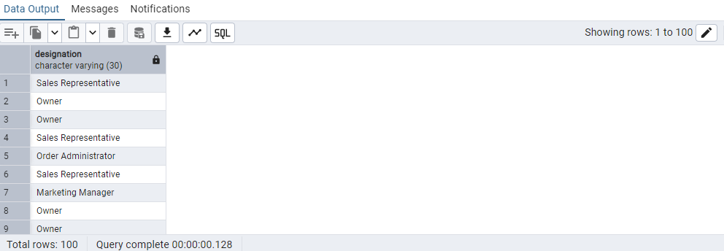

4. Find categories that have both discontinued and in-stock products

(Display category_id, instock means units_in_stock > 0, Intersect)

select category_id from products

where discontinued = 1

**intersect**

select category_id

from products

where units_in_stock > 0

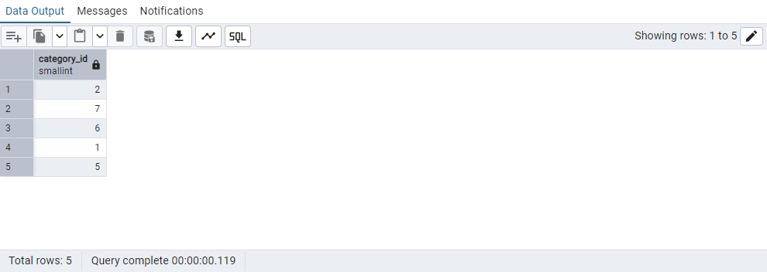

5. Find orders that have no discounted items (Display the order_id, EXCEPT)

select order_id from order_details

**except**

select order_id from order_details

where discount = 0

